Qiming Jin

11/11/2019

IT FDN 100 A Au 19: Foundations Of Programming: Python

Assignment 06

# Knowledge Document

## Assignment

Modify the script that manages a "ToDo list” by adding functions to organize the code.

## Steps

1. Based on the starting template provided. Create a “ToDoFile.txt” and put some example data in there.
2. According to the template and add more functions as necessary.
   1. Create funtions IO.GetInput() to get input from users.

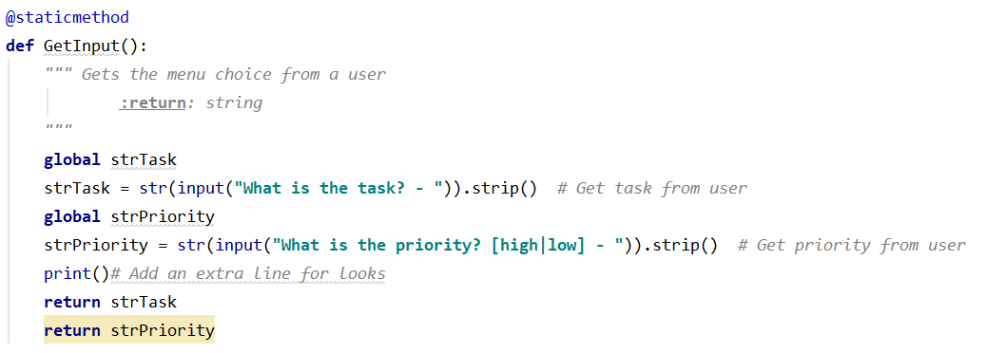

2.2 And then create a new funtion called AddItem to add the item to the list.

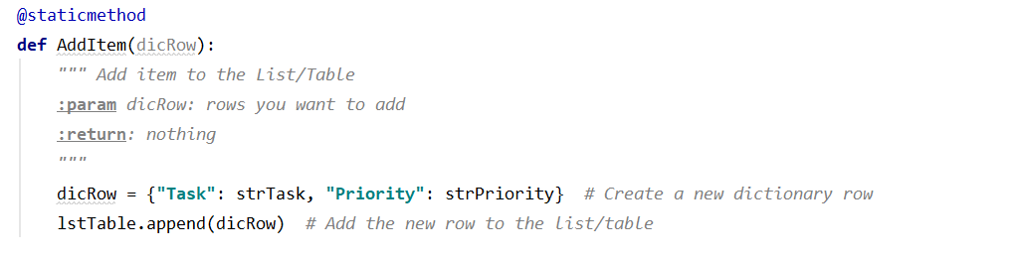

2.3 Realize the option 2 by running functions together.

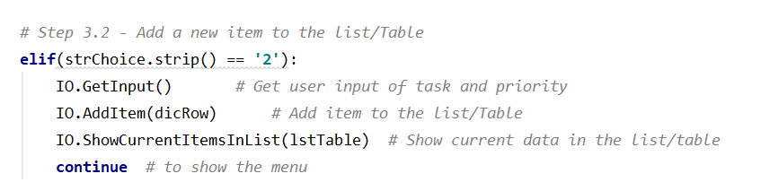

1. When users choose option 3 to remove item from the list/table.
   1. Based on the code already have in the template, create a corresponding function RemoveItem().

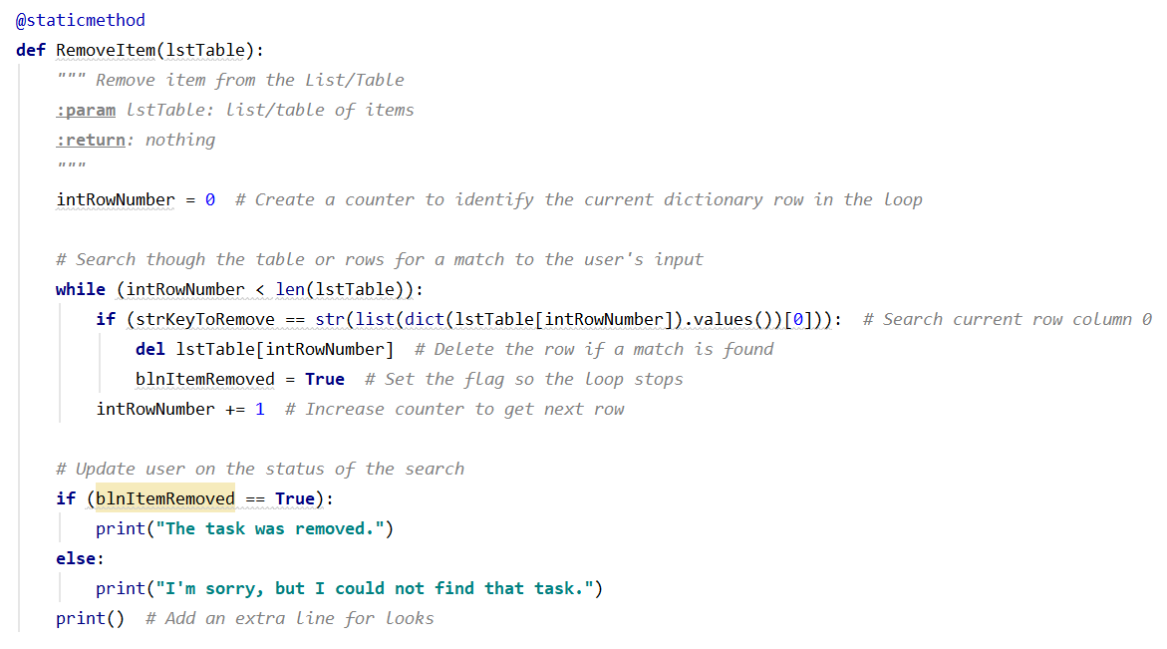

* 1. So when users choose option 3, remove the item from the list by running the function.

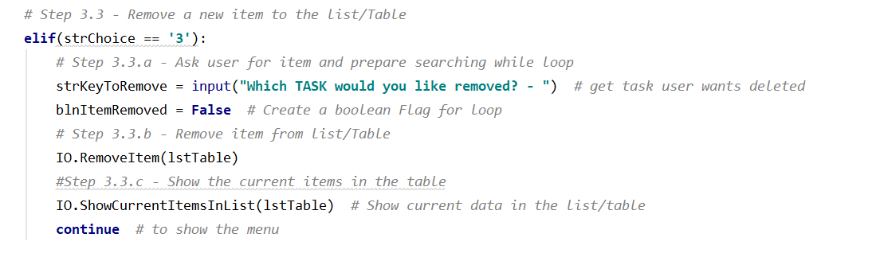

1. When users choose option 4 to write current data to local file.
   1. Create a function WriteListDataToFile() under Class FileProcessor.

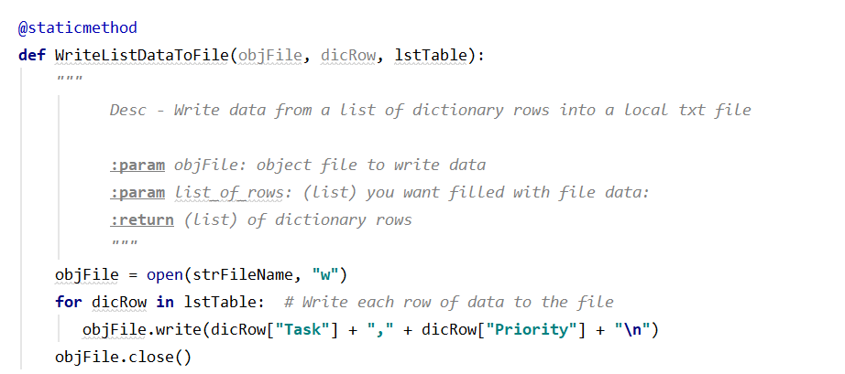

4.2 After confirming with users whether they want to save data to file, run the function.

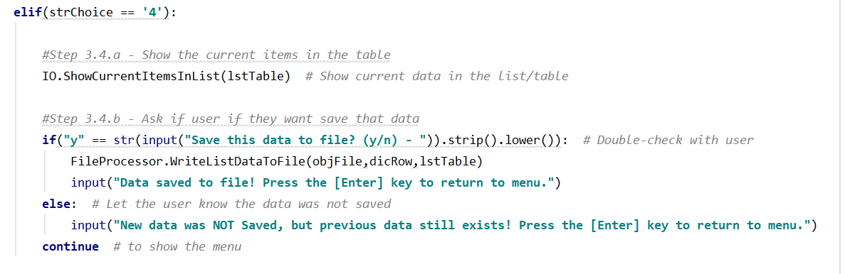

1. Use the code in template for option 5 and 6.
2. Run the script in PyCharm and test if it works.

6.1 Read and print current data from local file.

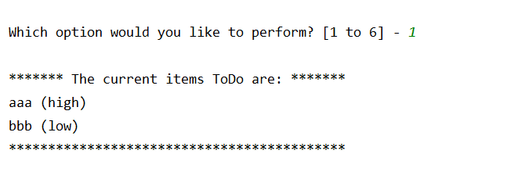

6.2 Add a new item to the list/table.

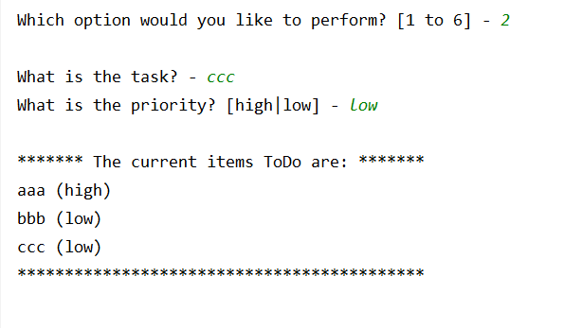

6.3 Remove the existing item from list/table.

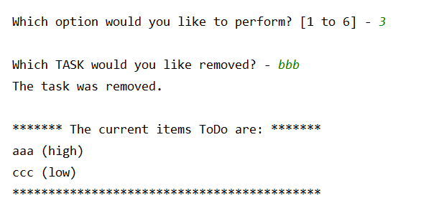

6.4 Save data to the local file.

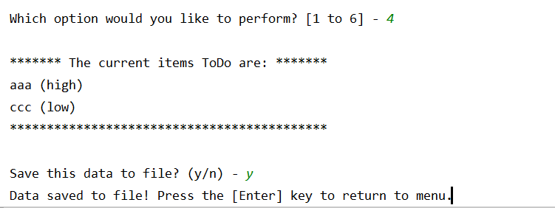

1. Run the script in OS command/shell window and test if it works.

7.1 Read and print current data from local file.

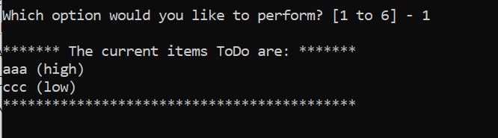

7.2 Add a new item to the list/table.

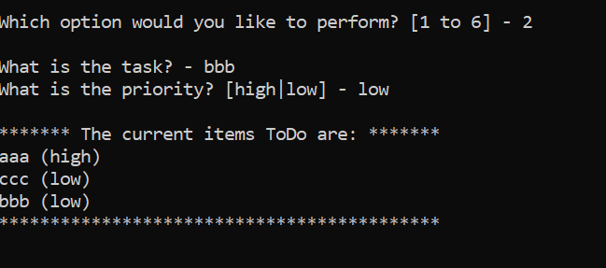

7.3 Remove the existing item from list/table.

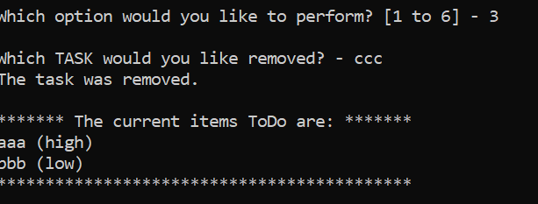

7.4 Save data to the local file.

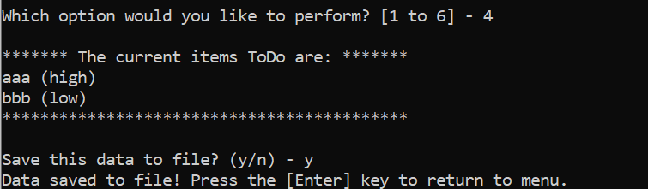

1. Check the data in text file.

8.1 Start:

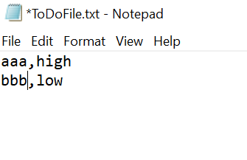

8.2 After change:

